Zeemal Sahoota
E-mail: zeemalsahoota1234@gmail.com
Phone: +92 3247666764

PEROSNAL INFORMATION

Recent Software Engineering graduate from CUI Sahiwal with a strong foundation in software quality assurance and problem-solving. Academic projects and hands-on experience with modern technologies have strengthened my technical and analytical skills while enabling me to work effectively in collaborative team environments. Passionate about learning emerging technologies, building innovative software solutions, and continuously improving my expertise. Eager to contribute to a dynamic organization where I can apply my knowledge, gain practical experience, and grow as a software engineering professional.

SKILLS & ABILITIES

Flutter Mobile App Development Data Analysis and Visualization
Software Development Life Cycle (SDLC) Google Colab & Jupyter Notebook
UI/UX Design Fundamentals

WORK EXPERIENCE

Flutter Developer Intern | October 2025 – November 2025 TechStep | Sahiwal, Pakistan

- Developed and maintained cross-platform mobile applications using Flutter and Dart.
- Built responsive and user-friendly UI screens following modern mobile app design principles.

EDUCATION

- BSSE | 2022-2026
COMSATS University Islamabad, Sahiwal Campus
CGPA: 3.51/4.00

- Intermediate | 2020 - 2022
Govt. Crescent Graduate College for women, Chichawatni

- Matriculation | 2018 - 2020
The Educators Girls High School Sahiwal

CERTIFICATIONS

- UX/UI Design Fundamentals: Usability and Visual Principles – SkillUp (Coursera) Learned core UX/UI principles, usability, visual hierarchy, wireframing, accessibility, and user-centered design for creating intuitive digital products.

Verify Certificate:
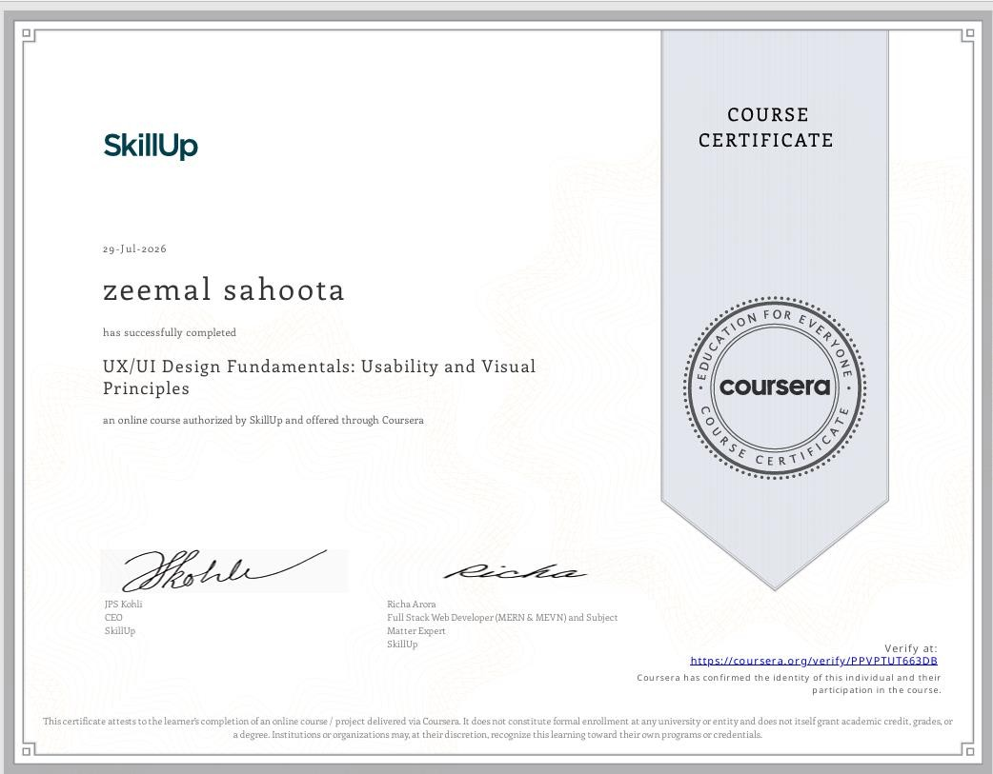
https://www.coursera.org/account/accomplishments/verify/PPVPTUT663DB

UI/UX Wireframing and Prototyping with Figma – SkillUp (Coursera)
Learned to create low-fidelity and high-fidelity wireframes, interactive prototypes, user flows, and responsive UI designs using Figma while applying user-centered design principles

Verify Certificate:
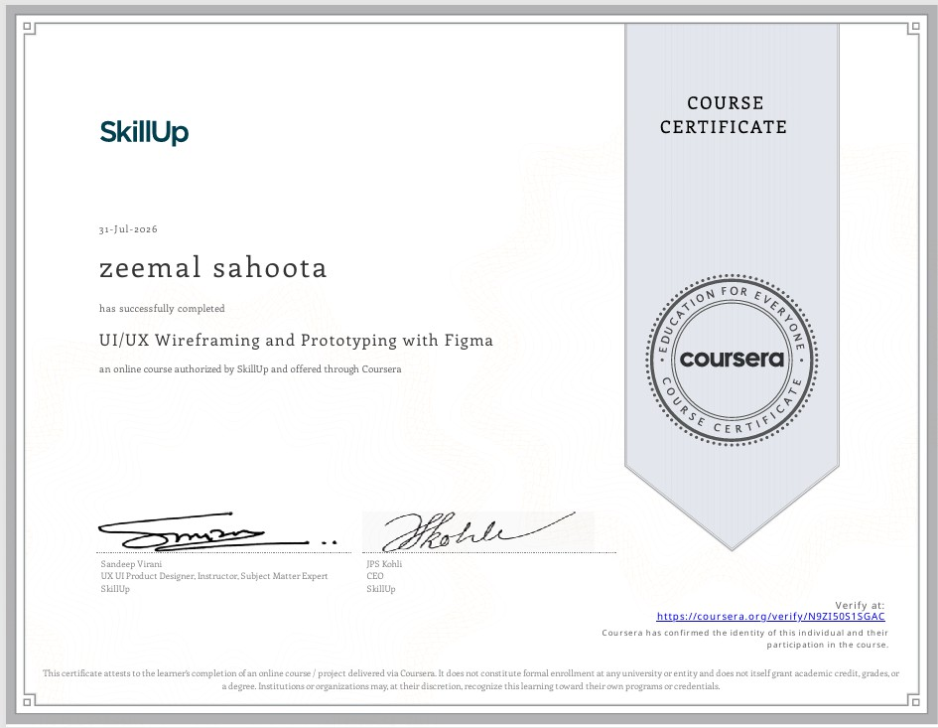
https://www.coursera.org/account/accomplishments/verify/N9ZI50S1SGAC

- UI/UX Design Fundamentals & Prototyping with Generative AI – SkillUp (Coursera) Learned UI/UX design fundamentals, usability testing, interaction and visual design, wireframing, prototyping, responsive UI design, and the use of Generative AI for ideation, personalization, and design optimization.

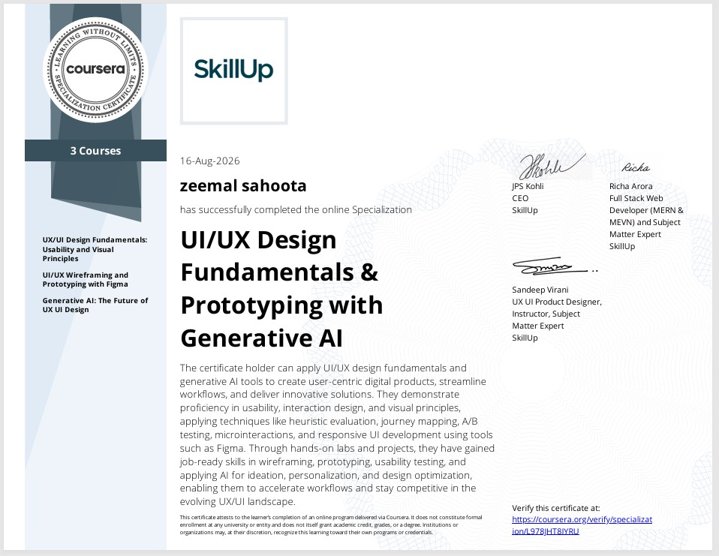
Verify Certificate: https://www.coursera.org/account/accomplishments/specialization/L978JHT8IYRU

